**Project Title**:

**Team ID: NM2025TMID39939**

**Team Leader : SIVAKUMAR G V**

**Mail ID** : sivakumargv2005@gmail.com

**Team Members**:

* AJAYKRISHNAN H :
* RAHUL MUTHU P :
* ATHULRAJ R P :

**Project Overview:**

* **Purpose:**
* **The primary objective of InsightStream is to establish a user-friendly platform tailored for individuals who are passionate about staying informed, exploring diverse news topics, and accessing the latest updates.**
* **Our key goals include:**
* **User-Friendly Experience: Develop an interface that is intuitive and easy to navigate, ensuring users can effortlessly access, save, and share their preferred news articles.**
* **Comprehensive News Management: Provide robust features for organizing and managing news content, incorporating advanced search options for a personalized news experience.**
* **Technology Stack: Employ c**
* **Features:**
* **News from API Sources:** Access a vast library of global news spanning various categories and interests, ensuring a well-rounded coverage of current affairs.
* **Visual News Exploration:** Discover breaking stories and explore different news categories through curated image galleries, enhancing the visual appeal of news discovery.
* **Intuitive Design:** Navigate the application seamlessly with a clean, modern interface designed for optimal user experience and clarity in information presentation.
* **Advanced Search Feature:** Easily access news articles on specific topics through a powerful search feature, providing users with tailored news content based on their interests.
* **Architecture:**

**UI of the application --- API client --- Rapid API(backend)**

* **Component Structure:**
* React Js
* React Router Dom
* React Icons
* Bootstrap/tailwind css
* Axios

**Setup Instructions**:

* **Prerequisties**:
* Node.js
* Mongodb
* **Installtion:**
* Clone the Repository: PS C:\Users\BSC 29\Downloads\code-20250918T040631Z-1-001.zip
* Install Dependicies: npm install
* Run the application :npm start

**Folder Structure**:

/src

|_components

|_Footer.jsx

|_Hero.jsx

|_HomeArticles.jsx

|_NavbarComponents.jsx

|_NewsLetter.jsx

|_TopStories.jsx

|_\context

|_CategoryPage.jsx

|_HomePage.jsx

|_NewsPage.jsx

|_\style

|_ CategoryPage.css

|_Footer.css

|_ Hero.css

|_ Home.css

|_ HomeArticles.css

|_ Navbar.css

|_NewsLetter.css

|_NewsPage.css

|_ TopStories.css

|_App.css

|_App.js

|_index.js

**Running the Application:**

* Frontend- cd client npm start
* Backend-Cd server npm start
* Access:Visit <http://localhost:3000>

**API Documentation**:

* **User**:

-/api/user/register

-/api/user/login

* **Projects:**

-/api/projects/create

-/api/projects/:id

* **Application:**

**-/api/apply**

**Authentication:**

**User Interface:**

* Clean and intuitive layout optimized for smooth navigation
* Mobile-first design for seamless browsing
* Elegant light/dark mode toggle for improved accessibilty

**Testing:**

* Jest for unit testing
* React Testing Library for component testing
* Code Coverage:Ensured high test coverage with jest reports

**Screenshots or Demo:**

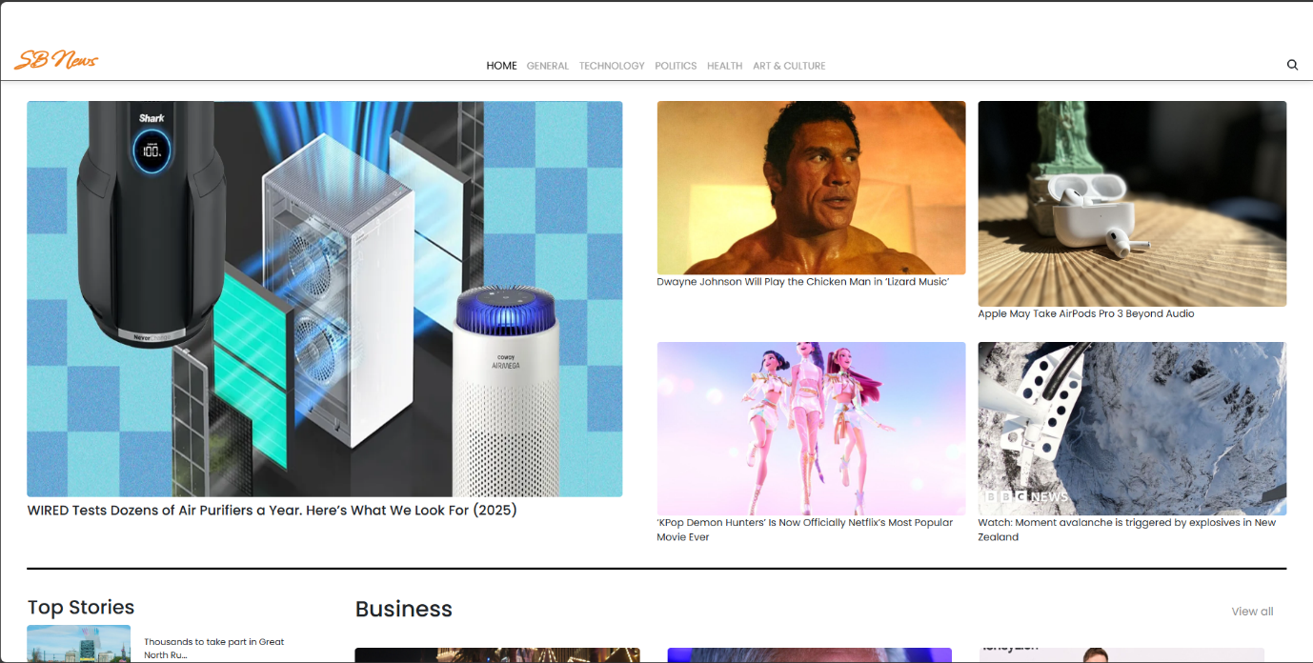

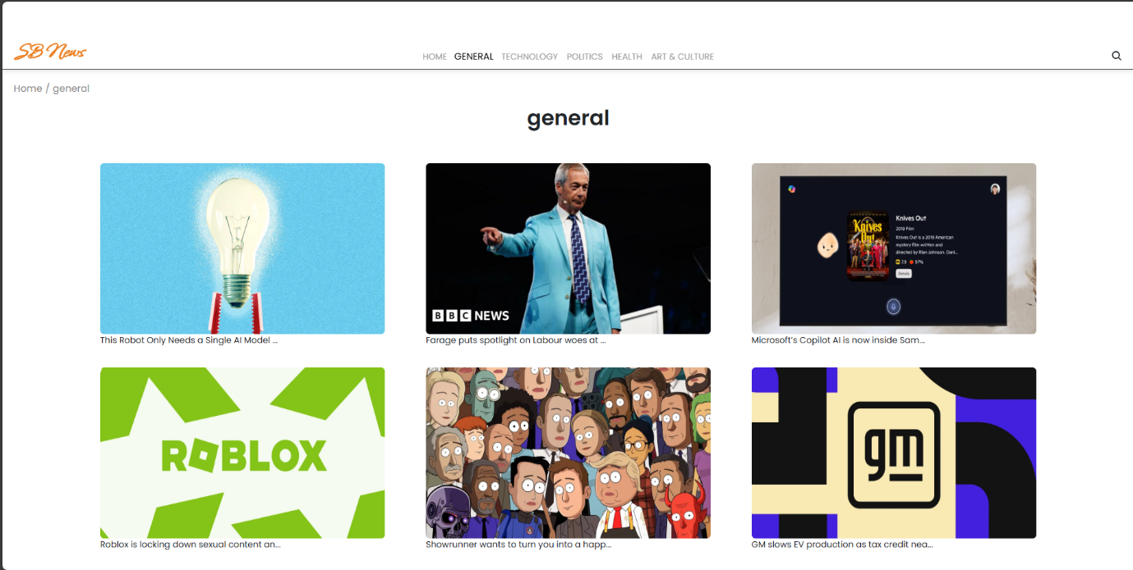

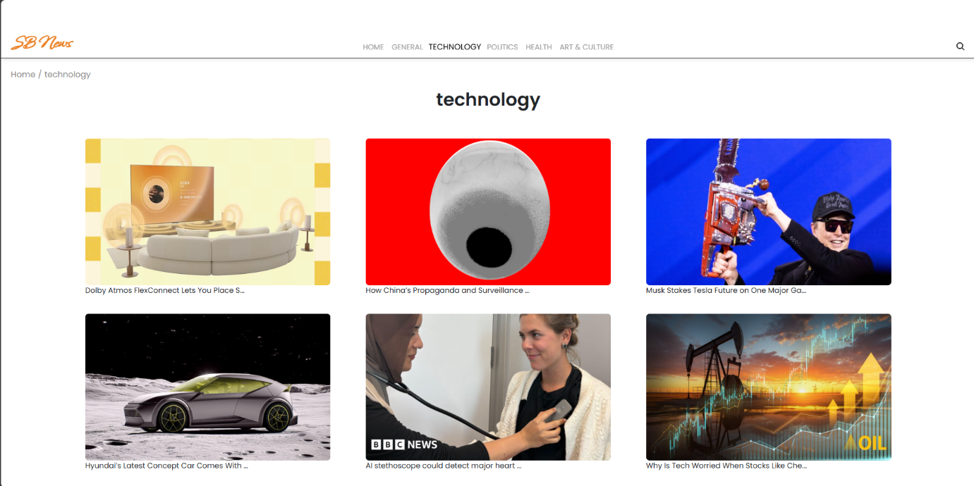

**Live demo link:**

**Known Issues:**

* Certain API endpoints may experience delays during peak traffic

**Future Enchancement**:

* AI-Based Recipe Suggestions
* User Authenciation for personalized recipe collection
* Offline Mode for accessing saved news